Prefix Sum QUESTIONS

Table of Contents
Theory 2
What is Prefix sum? 2
Examples of usage of prefix sum 2
1. Efficient Range Sum Queries: 2
2. Counting occurrence in range: 3
3. Equal subarrays: 3
https://leetcode.com/problems/number-of-ways-to-split-array/ 4
Important questions 5
1. Find the pivot integer 5
LEVEL 1: Amateur 6
1. ererfer 6
LEVEL 2: Pro 7
1. Unique length 3 palindromic subsequences 7
2. Shifting Letters II 7
IMP Question 9
LEVEL 3: Legend 11
SOLUTIONS: 12
LEVEL 1: 12
LEVEL 2: 13

Theory

What is Prefix sum?
A prefix sum is an array derived from an input array such that the value at each position in the prefix sum array is the sum of all elements up to that position in the original array. Mathematically, if the input array is A and the prefix sum array is P, then P[i]=∑j=0i​A[j].
Usually used for range queries.
Eg:-
If A = [2, 3, 5, 9]
Prefix Sum = P
P[0] = A[0] , P[1]=A[0]+A[1] ,P[2] = A[0]+A[1]+A[2] ,P[3] = A[0]+A[1]+A[2]+A[3]
So P = [2, 2+3, 2+3+5, 2+3+5+9] = [2, 5, 10, 19]
It is also equivalent to, P[i] = P[i-1] + A[i]
def fillPrefixSum(arr, n, prefixSum):
prefixSum[0] = arr[0]
# Adding present element with previous element
for i in range(1, n):
prefixSum[i] = prefixSum[i - 1] + arr[i]

# Driver code
if __name__ == '__main__':
arr = [10, 4, 16, 20]
n = len(arr)
prefixSum = [0 for i in range(n + 1)]
fillPrefixSum(arr, n, prefixSum)
print(prefixSum)
#output: [10,14,30,50,0] ( here we have 0 at end, can have it at start too)

Examples of usage of prefix sum

Efficient Range Sum Queries:
Prefix sums are often used to quickly calculate the sum of elements within a given range in an array. Example: Given an array arr, prefix_sum[i] can be used to calculate the sum of elements from index 0 to i efficiently.
def range_sum_query(prefix_sum, left, right):
return prefix_sum[right] - prefix_sum[left - 1] if left > 0 else prefix_sum[right]

# Example usage:
arr = [1, 2, 3, 4, 5]
prefix_sum = [0] + [sum(arr[:i+1]) for i in range(len(arr))]
#not an effiecient way to find prefix_sum
print(range_sum_query(prefix_sum, 1, 3)) # Output: Sum of elements from index 1 to 3

Counting occurrence in range:
Prefix sums can be used to efficiently count the occurrences of a value in a given range.
Example: Given an array arr, prefix_sum[i] represents the count of a specific value up to index i.
Approach: here prefix sum will save the count of occurrence of the value
#get occurences of num in given range[l,r] inclusive(for l,r 1-based index)
def get_occurrences(arr,val,left,right):
n = len(arr)
prefix_sum = [0]*(n+1) #will keep 0 in start
for i in range(1,n+1):
if arr[i-1]==val:
prefix_sum[i] = prefix_sum[i-1] + 1
else:
prefix_sum[i] = prefix_sum[i-1]
return prefix_sum[right]-(prefix_sum[left - 1] if left > 0 else 0)

# Example usage:
arr = [1, 2, 2, 3, 4, 2, 5]
# Output: Count of occurrences of 2 in the range [1, 5] ->[1,2,2,3,4] =2
print(get_occurrences(arr, 2, 1, 6))

These examples showcase how prefix sums can be used to efficiently solve various problems related to range queries, subarray sums, and counting occurrences. They help reduce time complexity by precalculating cumulative sums.

Equal subarrays:
Check if there are two subarrays with same sum.
Example: Given an array arr, prefix_sum[i] represents the count of a specific value up to index i.
Approach: here prefix

https://leetcode.com/problems/number-of-ways-to-split-array/

class Solution:
def waysToSplitArray(self, nums: List[int]) -> int:
n = len(nums)
pre = [0]*n

pre_sum=0
for i in range(n):
pre_sum += nums[i]
pre[i] = pre_sum

pairs=0
last = pre[-1]

for i in range(n-1): #only till n-1 to have atleast one value in right subarray
if pre[i] >= last-pre[i]:
pairs+=1
return pairs

Difference Array concept:

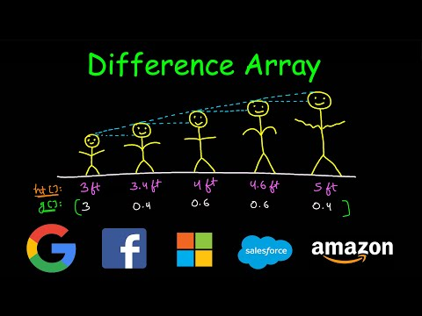

Important questions

Find the pivot integer
Given a positive integer n, find the pivot integer x such that: The sum of all elements between 1 and x inclusively equals the sum of all elements between x and n inclusively. (easy)
Link: https://leetcode.com/problems/find-the-pivot-integer/description/
Approach:-
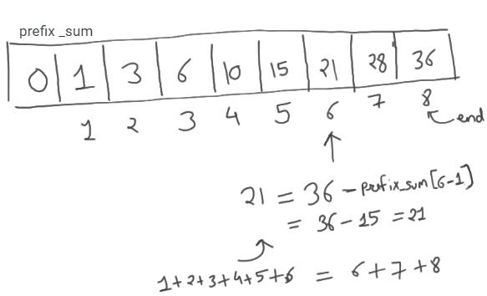
class Solution:
def pivotInteger(self, n: int) -> int:
prefix_sum = [0]*(n+1)

for i in range(1,n+1):
prefix_sum[i] = prefix_sum[i-1] + i

ans = -1
end = prefix_sum[-1]
for i in range(1,n+1):
if(prefix_sum[i] == (end-prefix_sum[i-1])):
ans = i
break
return ans

Approach 2
By observation, if total sum till n = a perfect square, then pivot integer is square root of sum
n=4
x = (n*(n+1)/2)**0.5
print(x,x%1) #3.1622777..., 0.162277..
print(-1 if x%1 else int(x)) #x%1 is way to check if number is whole number

n=8
x = (n*(n+1)/2)**0.5
print(x,x%1) #6.0 , 0.0
print(-1 if x%1 else int(x))



LEVEL 1: Amateur

ererfer
Link:

LEVEL 2: Pro

https://www.youtube.com/watch?v=80Zug6D1_r4

Unique length 3 palindromic subsequences
Link: https://leetcode.com/problems/unique-length-3-palindromic-subsequences/description

https://www.youtube.com/watch?v=0rTkpQC8ytY
class Solution:
def countPalindromicSubsequence(self, s: str) -> int:
d = {}
n = len(s)

#to get first and last occurrences
for i in range(n):
if s[i] in d:
d[s[i]][1] = i
else:
d[s[i]] = [i,i]

subs = 0
for c in d.keys():
f,l = d[c][0],d[c][1] #first and last occurrences of character
subs += len(set(s[f+1:l])) #f+1 else it will include c in that set

return subs

Shifting Letters II
Link: https://leetcode.com/problems/shifting-letters-ii/description/

Remainder theorem:
To get remainder of –a%b = b – (a%b)
- -7%5 = 5 – (7%5) = 5-2 = 3
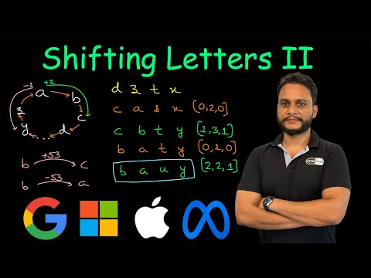
#For each query [l,r,t] - A is net shift after all shifts done
# a) if t==1 (right shift) , then A[l] += 1 and A[r+1] -= 1 if(r+1) < n.
# b) if t==0 (left shift) , then A[l] -= 1 and A[r+1] += 1 if(r+1) < n.

class Solution:
def shiftingLetters(self, s: str, shifts: List[List[int]]) -> str:

alphabet = 'abcdefghijklmnopqrstuvwxyz' # to get letters in loop
d = {} #to get index of char faster
for i in range(26):
d[alphabet[i]] =i

arr = list(s)
n = len(s)
A = [0] * n

#logic for difference array
for l, r, t in shifts:
if t == 1:
A[l] += 1
if r + 1 < n:
A[r + 1] -= 1
else:
A[l] -= 1
if r + 1 < n:
A[r + 1] += 1

for i in range(1, n):
A[i] += A[i - 1]

#Note (-1%26 = 25)
#logic to update our arr
for i in range(n):
c = A[i]
index = (d[arr[i]] + c) % 26 #Imp
arr[i]= alphabet[index]

return ''.join(arr)

https://leetcode.com/problems/minimum-number-of-operations-to-move-all-balls-to-each-box

Solution: https://leetcode.com/problems/minimum-number-of-operations-to-move-all-balls-to-each-box/submissions/1499647872/?envType=daily-question&envId=2025-01-06

IMP Question

Q: https://leetcode.com/problems/subarray-sum-equals-k/description/
Ans: https://www.youtube.com/watch?v=fFVZt-6sgyo

from collections import defaultdict

class Solution:
def subarraySum(self, arr: List[int], k: int) -> int:
ans = 0
currSum = 0
prefixSums = defaultdict(int)
prefixSums[0] = 1

for num in arr:
currSum += num
diff = currSum - k
ans += prefixSums[diff]
prefixSums[currSum] += 1

return ans

Similar q: https://www.geeksforgeeks.org/dsa/longest-sub-array-sum-k/

class Solution:
def longestSubarray(self, arr, k):
ml = 0 #maxLength
currSum = 0
mp = {} #holds first time given sum is present
mp[0] = -1

for i in range(len(arr)):
currSum += arr[i]
diff = currSum - k

if diff in mp:
ml = max(ml, i-mp[diff])

if currSum not in mp:
mp[currSum] = i

return ml

LEVEL 3: Legend

SOLUTIONS:

LEVEL 1:

LEVEL 2:

